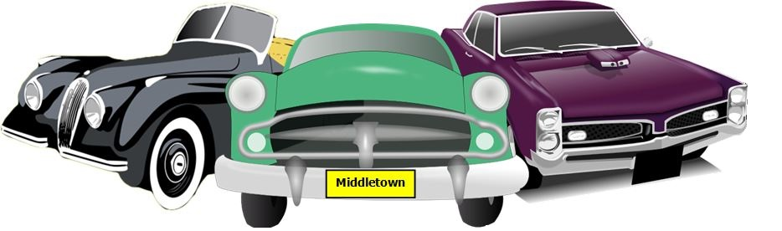
GREAT FOOD!
MUSIC!
Pre-registration $15.00 (until 8/16/25), Day of show $20.00
All proceeds to benefit the King of Kings Lutheran Church
Any questions, please call Gerry Conte 732-600-1186
NO alcoholic beverages. NO vendors.
Show is open to all years, makes and models
Trophies awarded including Pastor’s Pick Award, and Kid’s Choice
Dash Plaques and Goodie Bags
Great Food and Refreshments available for purchase
Outstanding Music, Parking lot with several shaded sections
King of Kings Lutheran Church
Annual Car Show
Saturday, August 23, 2025 (Rain Date 9/6/25)
10am to 2pm (Registration opens at 9am)
250 Harmony Road, Corner of Harmony and Cherry Tree Farm Roads
Middletown, NJ 07748
Prizes!

Trophies!

Car Show Registration Form
Make checks payable to: King of Kings Lutheran Church
Car Show Registration Form
Make checks payable to: King of Kings Lutheran Church
Please mail check and completed / signed registration form to:
Gerry Conte PO Box 654 Keansburg, NJ 07734

Name: _________________________________________________________________________________________________
Vehicle Make: ____________________________________ Model: ______________________________ Year: _____________
Phone: _______________________________________ Email: ____________________________________________________
Club Affiliation: __________________________________________________________________________________________
I hereby release the King of Kings Lutheran Church and anyone connected with this car show, from any and all responsibility for any illness, injuries, accidents, damage or theft that may occur to me, my vehicle, or my property while at this show. I will also be responsible for all guests entering this show with me.
Signature: ______________________________________________ Date: _________________________
Sorry No Refunds

